Operational Concept Description (OCD)

Somatis Web and Data Services

Team 03

Name | Roles
Fall 2012
Fei Qu | Project Manager
Jizhou Lu | Life Cycle Planner, Operational Concept Engineer
Xianan Fan | Prototyper
Dian Peng | Architect, Feasibility Engineer
Qiuyang Liu | Requirements Engineer
Jordan Padams | IIV&V
Spring 2013
Jordan Padams | All

Version History
Date | Author | Version | Changes made | Rationale
10/03/12 | JL | 1.0 | - Original version | - Initial draft
10/03/12 | QL | 1.1 | - Added section 2.1 | - To provide the program model as well as the benefits chain realization
10/03/12 | DP | 1.2 | - Added section 1.1  - Added section 1.2 | - To provide brief introduction for the environment and background of the target project
10/03/12 | FQ | 1.3 | - Added section 2.2  - Added section 2.3 | - To provide current system boundary diagram  - To provide current system workflow diagram
10/09/12 | DP | 1.4 | - Modification of version history | - Fix inconsistent version history recording
10/15/12 | JL | 2.0 | - Complete all sections | - Be part of FC package
10/22/12 | JL | 2.1 | - Modification of all sections | - Draft FC package
10/24/12 | JL | 2.2 | - Add more details in section 2.2  - Add more details in section 3.2.3  - Modify current business workflow  - Modify new system business workflow | - Response to the Evaluation of Core FC Package
10/31/12 | JL | 2.3 | - Modification of all sections | - Response to the Evaluation of Draft FC Package
11/05/12 | JL | 2.4 | - Fix system boundary diagram  - Fix ER diagram  - Add security as a system capability | - Finalize the OCD being part of the final FC Package
11/14/12 | JL | 2.5 | - Modify new system business workflow | - Final version to response the Evaluation of FC Package
11/26/12 | JL | 3.0 | - Add a new LOS  - Fix system capability description | - Draft DC package
12/10/12 | JL | 3.1 | - Change business workflow of sensor configurator | - Final version to response the Evaluation of DC Package
2/11/13 | JP | 4.0 | - Transferred all work from original Architected Agile template to NDI/NCS Template.  - Changed System Boundary diagram to include Exosite  - Added new Operational Constraint | - RDCP
2/12/13 | JP | 4.1 | - Updated capability goals | - Priority levels were outdated

Table of Contents
Operational Concept Description (OCD) i
Version History ii
Table of Contents iii
Table of Tables iv
Table of Figures v
1. Introduction 1
1.1 Purpose of the OCD 1
1.2 Status of the OCD 1
2. Shared Vision 2
2.1 Benefits Chain 3
2.2 System Capability Description 3
2.3 System Boundary and Environment 5
3. System Transformation 6
3.1 Information on Current System 6
3.2 System Objectives, Constraints and Priorities 7
3.3 Proposed New Operational Concept 10
3.4 Organizational and Operational Implications 12

Table of Tables
Table 1: The Program Model 2
Table 2: Capability Goals 7
Table 3: Level Of Service Goals 8
Table 4: Relation to Current System 9

Table of Figures
Figure 1: Benefits Chain Diagram of Volunteer Tracking System 3
Figure 2: System Boundary and Environment Diagram 5
Figure 3: Current Business Workflow Diagram 7
Figure 4: Element Relationship Diagram 10
Figure 5: Business Workflow Diagram for Sensor Configurator 11
Figure 6: Business Workflow Diagram for Data Service 12

Introduction

Purpose of the OCD
This document provides, in detail, the shared visions and goals of the stakeholders of web-based product configurator and data service system.
The organization that launched this project is Somatis Technology Inc, which designs and manufactures custom tactile sensors for the robotics industry. This project is aiming at improving the current workflow of the configuration of their products for the customer and also providing convenient online sensor data management.
The success-critical stakeholders of the project are Dr. Nicholas Wettels, the president of the company Somatis; the USC CSCI-577A development team, which is responsible for the development of the project; maintainer team, which is responsible for the future updating and maintaining task for the web-sites and also the customers of the service.

Status of the OCD
Version 3.x of document includes work for the Draft DC Package, response to the Draft DC Package, and the final DC Package. The status of the current development is at the end of the foundation phase and the fall semester. The development team has negotiated with the client and settled down the requirements. And all the team members also have their assigned roles in the development process.
Version 4.0 of document included transition of multiple sections of the document in response to the selection of a new COTS product, Exosite. Changes were made to System Boundary diagram, Operational Constraints, and ER Diagram.

Shared Vision
Table 1: The Program Model
Assumptions
- Customer needs website configurator to customize products efficiently
- Customer needs a system to manage data
- A large amount of data need to be updated and returned in real time
- People desire more profits through internet activities
- Stable system and level of service are provided and maintained by Network Solutions
Stakeholders  (Who) | Initiatives  (What) | Value Propositions  (Why) | Beneficiaries  (Who)
- Sensor Buyer/User  - Developers  - Dr. Nick Wettels  - Mike Jackson  - Telecom Engineer (TBD)  - Maintainer | - Develop system  - Sensor Data Service  - Sensor Configurator  - Website improvement  - Provide tutorials  - SEO SEM  - Develop telecom network  - Launch product  - Beta testing  - Maintain system  - Further refine data management system | - Increased sales  - Increased profits  - Increased efficiency  - Increased data availability  - Increased flexibility of sensor module features.  - Increase company reputation  - Increase product quality  - System stability & level of service | - Customers  - Large corporations  - Tech savvy groups  - Somatis core team members
Legend:
Initiatives that need to be undertaken to help beneficiaries derive value from the expected benefits/value propositions
Initiatives that need to be undertaken to help deliver value to the beneficiaries (i.e. “how” will the benefits reach the beneficiaries?)

Benefits Chain

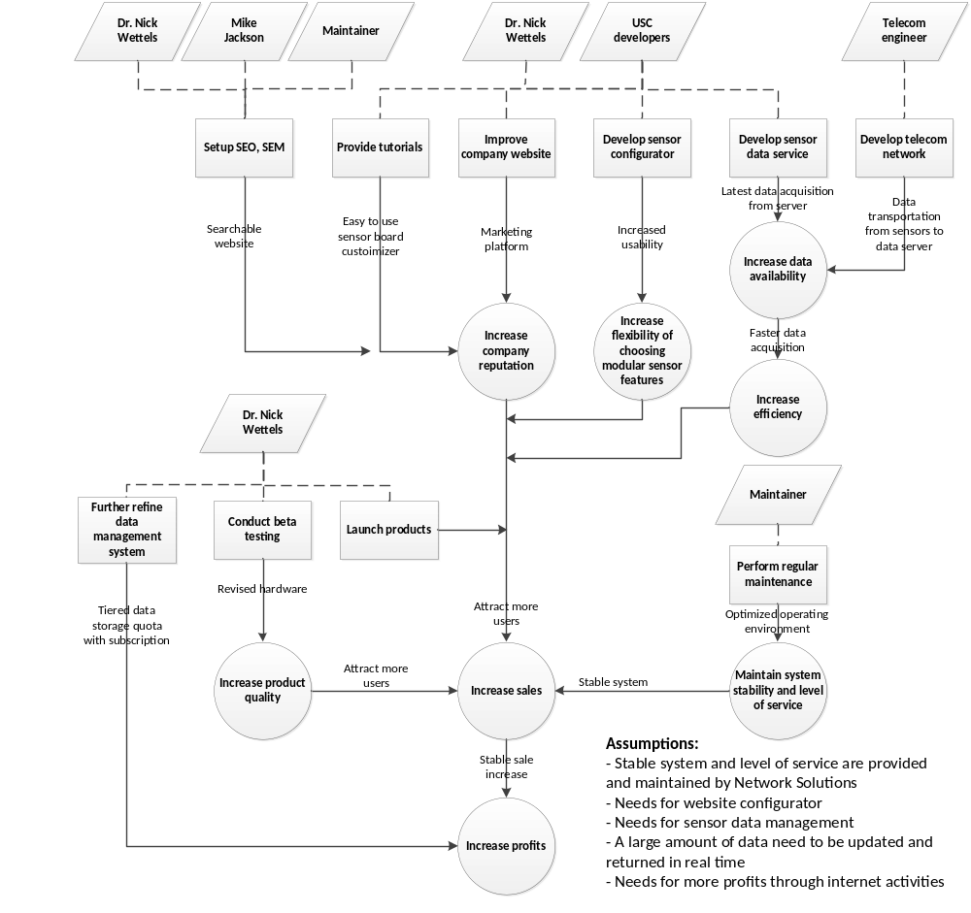
Figure 1: Benefits Chain Diagram of Volunteer Tracking System

System Capability Description
- The type of system to be built
It is a web-based project, which contains a public website with a product configurator to interface with customers and a data management system connected with hardware sensor system.
- The target customer(s) for the system
The target customers would be experts in the robotics and sensor industry who are seeking for professional services, such as customization of sensor product and capable data management. Besides that, the system also includes the newcomers of the company, whom lack professional background knowledge and need more technical assistance.
- The need or opportunity that will be satisfied by the system
Like it is stated above, the expert customers are seeking for the professional hardware sensor solutions. The project aims to provide a professional and efficient way for them to purchase and get management service. Besides that, the system also welcomes new customers and provides quick tutorials.
- A compelling reason for the customer to buy/use the system
The main reason for using the system is that it provides a customer base and visibility to a proprietary sensor technology with customized and professional service in the robotics and sensor industry. The company is a start-up proprietary sensor company, and the system will provide visibility for the company through a web site and increased customer base through the customization of sensors and a data portal to access sensor readings.
- The closest competitor of the system
There are many Machine-to-Machine (M2M) companies around that can provide the data services included with the Somatis sensors, i.e. Wyless, Exosite Portals (independent from Somatis), Raco Wireless, etc. However, the sensors developed by Somatis are proprietary, patented products. The data services are intended as an extra service to package with these sensors.
- The system's primary differentiation from, or benefit over, the closest competitor or alternative approach, if there are competitors or alternatives at the time
Our client is a start-up company and lacks of strong influence regarding to the competition with the competitor. The primary strength of the system is the integration of current hardware background and existing customer resources, providing professional and customized sensors and after-sale service to the sensor users.
- The system's security is also a concern preventing from hacking
Our system has to the sensor sending the data and the data being sent are authenticated and authorized to store data. NDI includes this service.

System Boundary and Environment

Figure 2: System Boundary and Environment Diagram
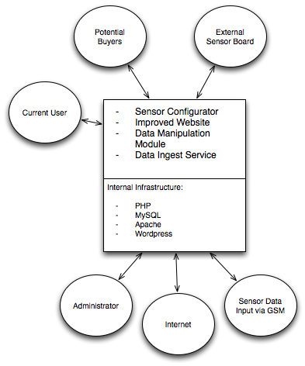

System Transformation

Information on Current System

Infrastructure
Hardware & Network:
Our client uses HostGator to host its server. And the database selected is MySQL. Currently, the sensors to be used haven't been selected yet.

Software:
Current website is done by HTML and CSS.

Artifacts
No artifact was created by the current system. There is only a homepage website regarded as the current system.

Current Business Workflow
Figure 3: Current Business Workflow Diagram

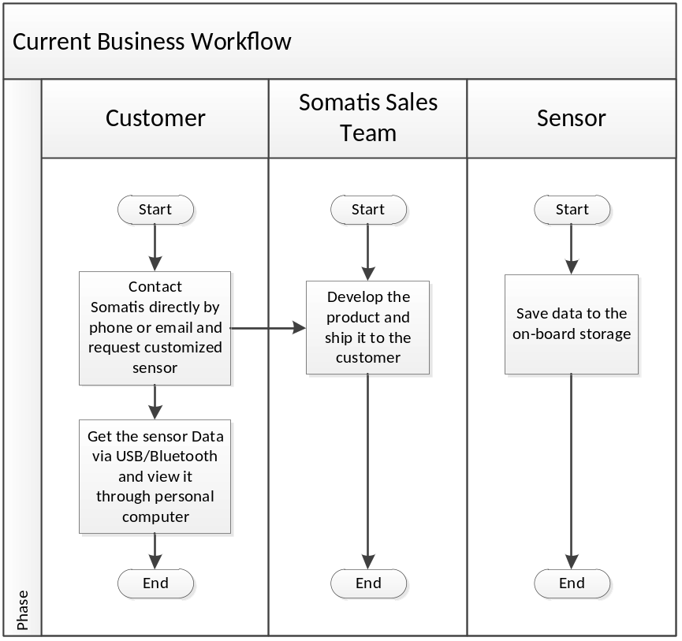

System Objectives, Constraints and Priorities

Capability Goals
Table 2: Capability Goals
Capability Goals | Priority Level
OC-1 Sensor Configurator: allows customer to customize product and place the order. | Must have
OC-2 Data Ingestion Service: inputs data from customers' sensor. | Must have
OC-3 Data Manipulation Service: displays and manages the sensor data. | Must have
OC-4 User Forum: provides a platform for user communication. | Potentially have
OC-5 Notification Service: notifies user the customized sensor data by text messages or emails. | Potentially have
OC-6 Social Media: integrates Facebook and Twitter. | Potentially have
OC-7 Web Content Update: updates information on website. | Potentially have
OC-8 Check Out: Customers pay for product and service by credit card on website and Somatis receives it electronically. | Potentially have

Level of Service Goals
Table 3: Level Of Service Goals
Level of Service Goals | Priority Level | WinWin Conditions
LOS-1: Supported Browsers: IE, Chrome, Firefox, Safari. | 9 | WC_1439
LOS-2: Maximum 50% down time for website. | 8 | WC_1440
LOS-3: At least 1 person can access database service at any given time, with possible expansion to 10 people in the future. | 10 | WC_1441
LOS-4: Maximum database downtime of 2 hours/month. | 8 | WC_1442
LOS-5: Secure communication between data ingestion module and user’s sensor. | 9 | WC_2256
LOS-6: No more than 10% of all data products transferred will have data loss during transfer due to hardware or network issues. | 8 | WC_2265

Organizational Goals
OG-: Increase profits for the company.
OG-2: Increase efficiency of the sensor data management process.
OG-3: Increase data availability of the back-end management system.
OG-4: Increase flexibility of sensor module features and strengthen the communication with the system.
OG-5: Create marketing tools through the website and existing customer, attract more customers.

Constraints
CO-1: Data Service Dependency on Wireless Module: The client will choose a GSM module to send sensor data to our server and that’s a critical constraint for our development team to consider.
CO-2: Limited Budget: The client won’t spend too much on the project. The ideal cost would be $2500.
CO-3: Web service provider: The current system is based on HostGator.
CO-4: Limited Cost Passed Onto Customer: Cost of Exosite services for each device must be within a reasonable amount in order to minimize the cost passed onto the customer. This amount is yet to be determined.
CO-5: Data Service Dependency on Exosite: By choosing Exosite as a COTS solution, Somatis is now dependent on Exosite Support in the case where errors occur.

Relation to Current System
Table 4: Relation to Current System
Capabilities | Current System | New System
Roles and Responsibilities | A website advertising the company | A comprehensive web system including register, login, browse, product configure, purchase
User Interactions | No interaction | Data connection between user's sensor and data ingest system & Customer purchases sensors on website
Infrastructure | Simple website, no database | A marketing website with product configurator and sensor data management system
Stakeholder Essentials and Amenities | Advertising the company | Support the company business
Future Capabilities | Be part of the new system | Contains daily routines such as selling products and providing data service

Proposed New Operational Concept

Element Relationship Diagram
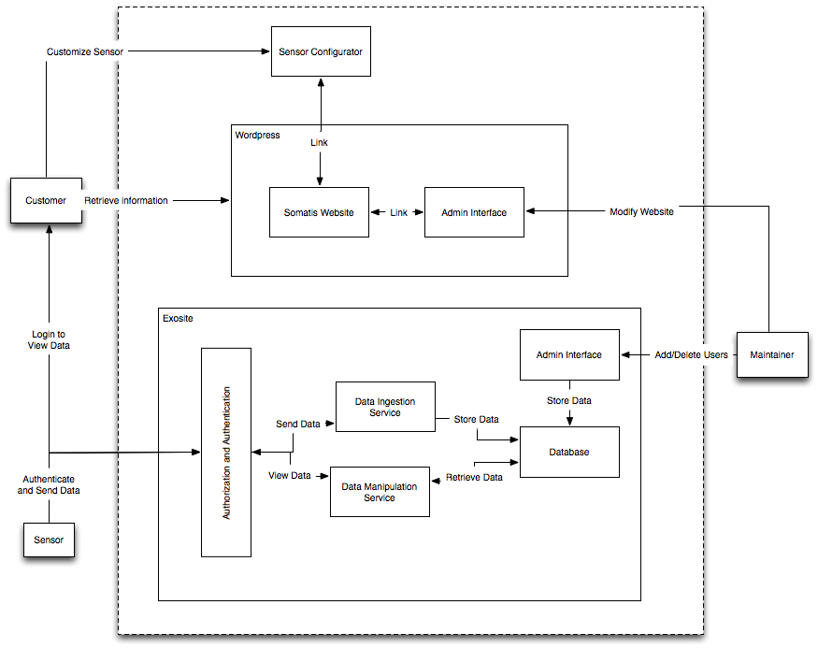
Figure 4: Element Relationship Diagram

Business Workflows
Figure 5: Business Workflow Diagram for Sensor Configurator
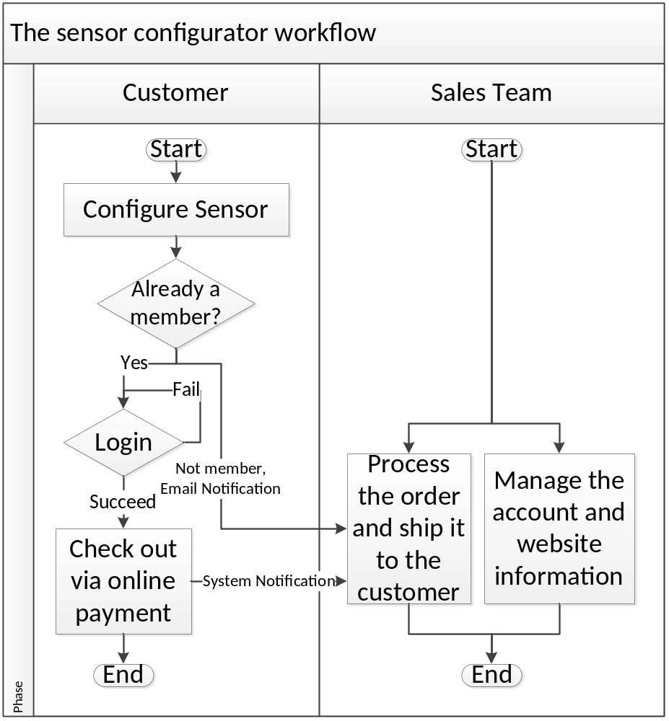

Figure 6: Business Workflow Diagram for Data Service
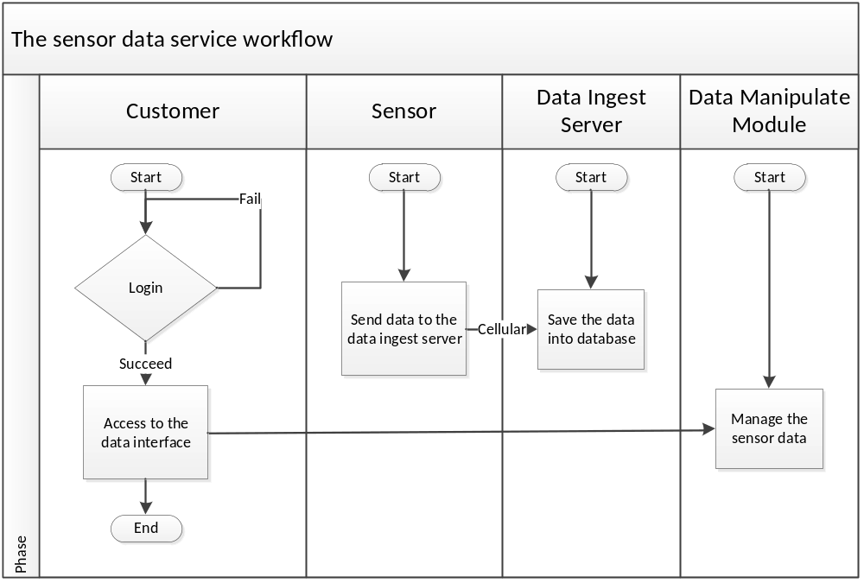

Organizational and Operational Implications

Organizational Transformations
- The need to hire a new system maintainer to take care of the system.
- The need for increased sales personnel since currently the company sales department is nonexistent.

Operational Transformations
- Integration the current static website with the new system
- With the business growing, the website usage capacity of the system might be a problem and need to be extended. And the work load of the maintainer will be increased.
- After the system being used, the customers can be regarded as beta testers and some problems within the system might be discovered. For such circumstance, the manager may need to hire some technical engineers to fix the system.

